**Q1.** Outstanding Persons

We judge a person if he is outstanding or not by the achievement in his/her profession. A professor and a student have different criteria for being called outstanding.

**Objective**: Understand overriding and polymorphism.

**Problem Statement**: Refer the class diagram snippet shown below and create the corresponding classes. Refer the business rules mentioned below and come up with a solution.

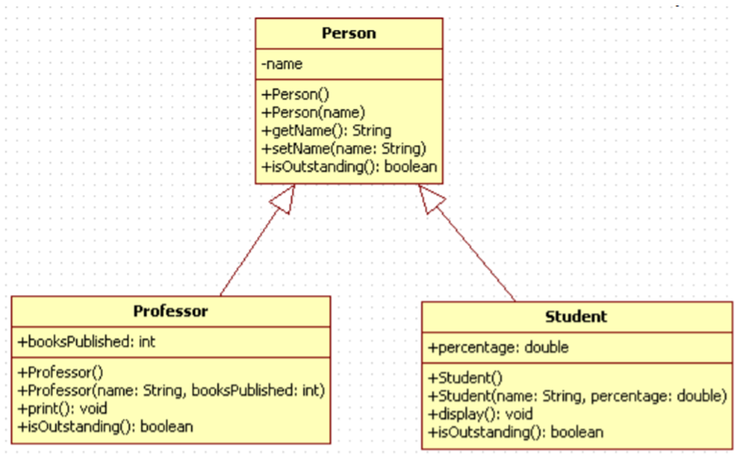

Professor is outstanding if he has published more than 4 books Student is outstanding if his percentage is greater than 85.

The print() method of Professor displays the name and books published by professor.

The display() method of Student displays the name and percentage of student.

In the application main method create 5 objects of Person type, this can be few Student Objects and remaining can be Professor Objects.

Every object has to be referred using Person reference (upcasting). To refer the objects use an array of Person.

Traverse through the Person array and display the person details only if the person is outstanding. The name and percentage should be displayed if the person referred is a Student. If the Person referred is a Professor, display name and books published.

**Q2. Collection Exercise**

For Book Shoppe, the information needs to be maintained about the books that are currently available. For maintaining the same, the user interface is provided in such a way that it allows the user to add the information about new books, to modify the information about the existing books like changing the price, publisher name or the author name and to remove the information about the unwanted books. Before updating or removing the book information firstly ensure that book exists by filtering the book information based on book name.

**Problem Statement**

Create a Books collection containing following default data:

|  |  |  |  |  |
| --- | --- | --- | --- | --- |
| **Book Code** | **Book Name** | **Publisher Name** | **Author Name** | **Price** |
| ASPNA | ASP.Net Profes-sional | Wrox | Bill Evjen, Matt Gibbs, | 750.00 |
| ASPNB | Beginning ASP.Net | TechMedia | Dan Wahlin, Dave Reed | 545.00 |
| LNQA | Learning LINQ | APress | Steve Eichert | 400.00 |
| CSPN | C# Developers Guide | Tata McGraw | Dan Maharry | 675.00 |

**Provide the following options**

1. Adding the information about new books.

2. Filter criteria to display book information based on the chosen **BookCode**. On choosing the ‘**View Codes’**, the existing code values from the collection should be displayed. When the user picks the value, the matching book row information should be displayed in the respective.

3. Modifying the filtered book information to update a matching row in the collection.

4. Deleting the filtered book information about existing books based on the filter criteria to delete a matching row in the collection.

(Note : Before Update or delete , the row should be filtered and displayed as well. )